**Rezolvarea laboratoarelor**

**Grupa 232 – 1**

**SGBD , 2023 – 2024**

**Forma răspunsurilor**

Mincu Adrian-Lucian – 1

Rezolvare

* Diagrama conceptuală

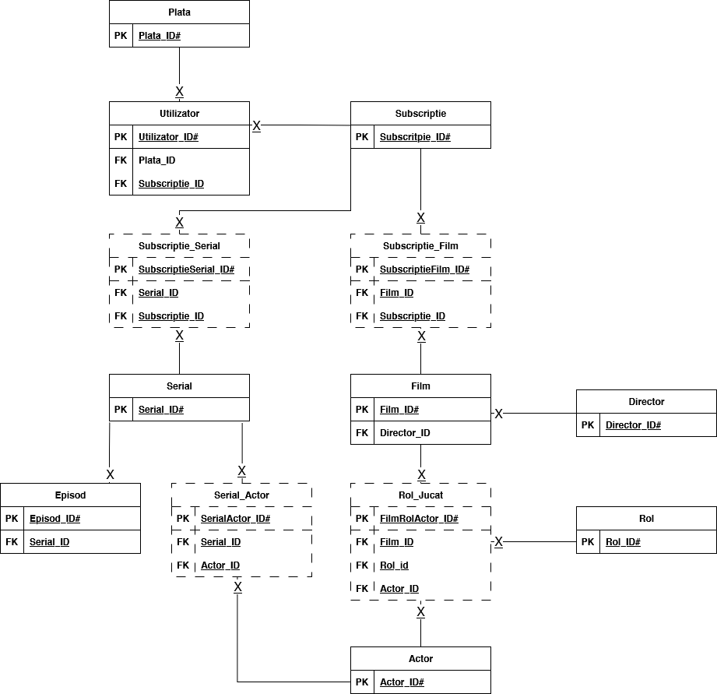

* Cod

spool D:\"UNI CODE"\Univeristy-Work\"Second Year"\"First Semester"\DBMS\Project\SpoolOutput\insert.sql  
insert all  
 into UTILIZATOR(utilizator_id, subscriptie_id, plata_id, porecla, mail, parola, data_exp_sub) values (101,55245,1001,'NovaFire','handsomeDaniel@gmail.com','RD_2003',*TO_DATE*('14/06/2023','DD/MM/YYYY'))  
 into UTILIZATOR(utilizator_id, subscriptie_id, plata_id, porecla, mail, parola, data_exp_sub) values (102,55245,1002,'Dingo','din.go@yahoo.com','39hsrda9',*TO_DATE*('05/05/2023','DD/MM/YYYY'))  
 into UTILIZATOR(utilizator_id, subscriptie_id, plata_id, porecla, mail, parola, data_exp_sub) values (103,55245,1003,'Zed999','duncan_thomas@yahoo.com','Zed_MY_life',*TO_DATE*('27/05/2023','DD/MM/YYYY'))  
 into UTILIZATOR(utilizator_id, subscriptie_id, plata_id, porecla, mail, parola, data_exp_sub) values (104,39959,1004,'Lulu','mun.benj@yahoo.com','Aida_2022',*TO_DATE*('22/05/2023','DD/MM/YYYY'))  
 into UTILIZATOR(utilizator_id, subscriptie_id, plata_id, porecla, mail, parola, data_exp_sub) values (105,39959,1005,'Kirby','stepehnson14@gmail.com','kirby1306',*TO_DATE*('14/05/2023','DD/MM/YYYY'))  
 into UTILIZATOR(utilizator_id, subscriptie_id, plata_id, porecla, mail, parola, data_exp_sub) values (106,39959,1006,'Joshuuuuua','josh.h@gmail.com','netflixPassword',*TO_DATE*('18/05/2023','DD/MM/YYYY'))  
 into UTILIZATOR(utilizator_id, subscriptie_id, plata_id, porecla, mail, parola, data_exp_sub) values (107,39959,1007,'happydog1234','happy.dog123@yahoo.com','dogggsAREsweet',*TO_DATE*('10/06/2023','DD/MM/YYYY'))  
 into UTILIZATOR(utilizator_id, subscriptie_id, plata_id, porecla, mail, parola, data_exp_sub) values (108,67933,1008,'RoninHack','martin_net@yahoo.com','genshin001',*TO_DATE*('01/06/2023','DD/MM/YYYY'))  
 into UTILIZATOR(utilizator_id, subscriptie_id, plata_id, porecla, mail, parola, data_exp_sub) values (109,67933,1009,'Matoka26','avaiscool@gmail.com','Mihai1234568',*TO_DATE*('08/06/2023','DD/MM/YYYY'))  
 into UTILIZATOR(utilizator_id, subscriptie_id, plata_id, porecla, mail, parola, data_exp_sub) values (110,78477,1001,'skpha','ray.ana@gmail.com','VulturViteaz',*TO_DATE*('15/06/2023','DD/MM/YYYY'))  
select 'worked' from dual;  
spool off;

* Capturi de ecran: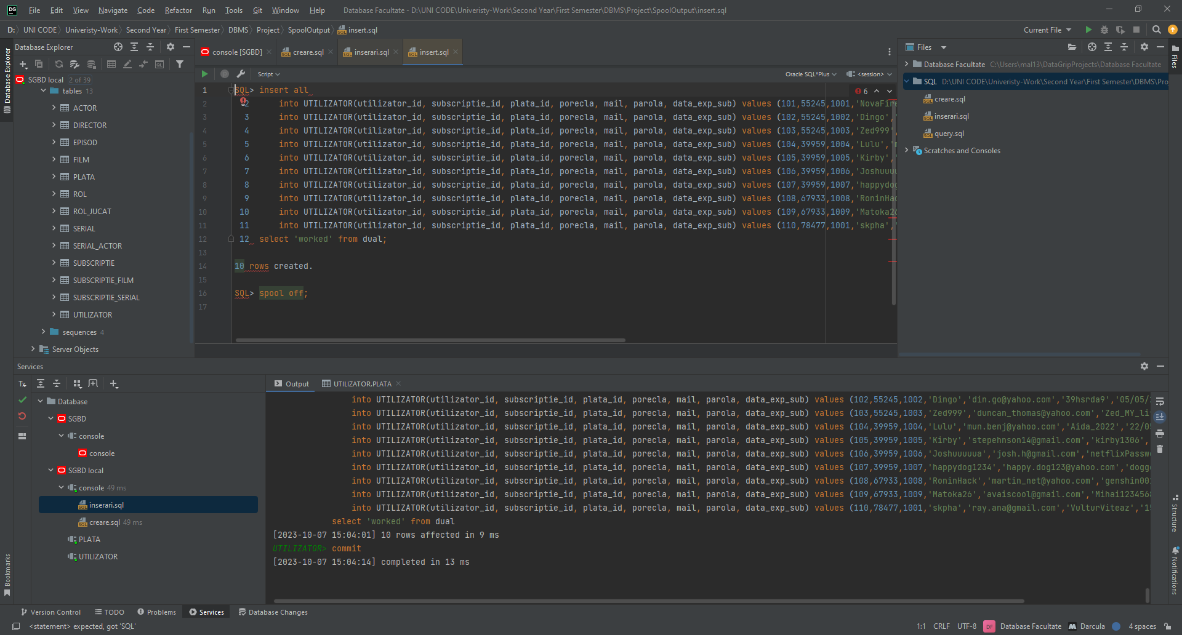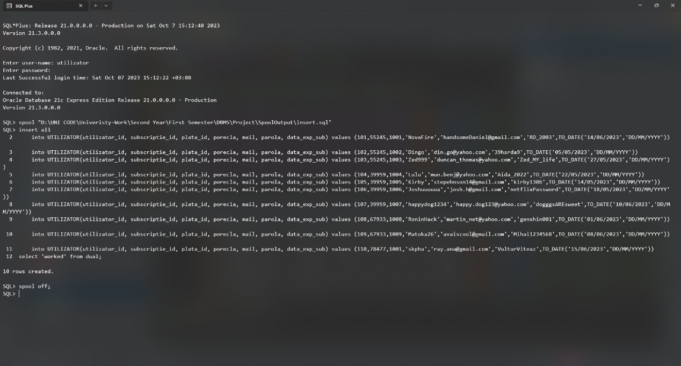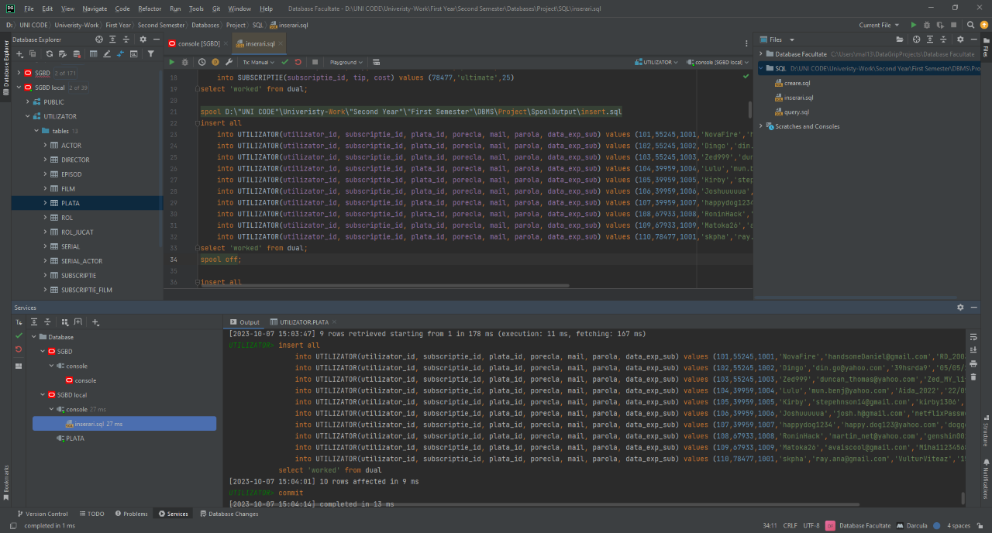
* Stergerea tabelelor:

spool 'D:\UNI CODE\Univeristy-Work\Second Year\First Semester\DBMS\Labs\L01\commands.sql'  
select 'DROP TABLE ' || table_name || ';'  
from user_tables;  
spool off;

* Captură de ecran:

